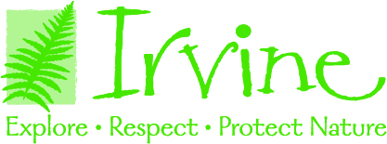

Naturalist

Undergraduate Internship

Organization Description:
Irvine Nature Center is a non-profit educational organization that offers programs of environmental studies and natural science to children and adults of the greater Baltimore area. We all thrive outdoors. We encourage lifelong engagement with the natural world through environmental learning and green living. At Irvine, we inspire people to explore, respect and protect nature.

Internship Description:
This internship is UNPAID, but eligible for academic or course credit if approved by your educational institution. Irvine Nature Center seeks creative, enthusiastic, and organized interns to prepare for and lead hands-on, outdoor environmental education programs for school-aged K-12 children. Interns will be trained to implement science-based lesson plans and will learn local natural history, and teaching techniques. Other general duties include assisting with live animal care and presentations, leading trail hikes, and student supervision. With guidance from supervisors, interns will create an individual long-term project spanning the internship. A short public presentation on the last day of the internship is highly encouraged.

Qualifications:
- Undergraduate student (2nd year or later) majoring in biology, animal science, education or a related field.
- Work experience with children grades K-12th.
- Strong interest in education.

Excellent communication skills.
- Familiarity with (or enthusiasm to learn) a variety of environmental education activities.
- Your own transportation.

Majors:
Early Childhood Education, Elementary Education, Outdoor Education, or Human Services. Natural sciences, Environmental Science or related fields also considered.

Hours:

20-30 hours per week (200-400 hours total).
- Must have availability between 8am-4pm (times may vary).
- Monday-Friday (possible weekend availability).
- Must be available for training dates.

Project:

Create a project to be presented at the end of the internship.
- Project examples include: Environmental lesson curriculum (3 lesson minimum), creation of science-based lesson materials, etc.

To Apply:
- Send Resume and 3 References to: Maggie Winkler, Visitor Services and Volunteer Coordinator, Irvine Nature Center, 11201 Garrison Forest Rd., Owings Mills, MD 21117.
- Email: winklerm@explorenature.org Phone: 443-738-9240

